[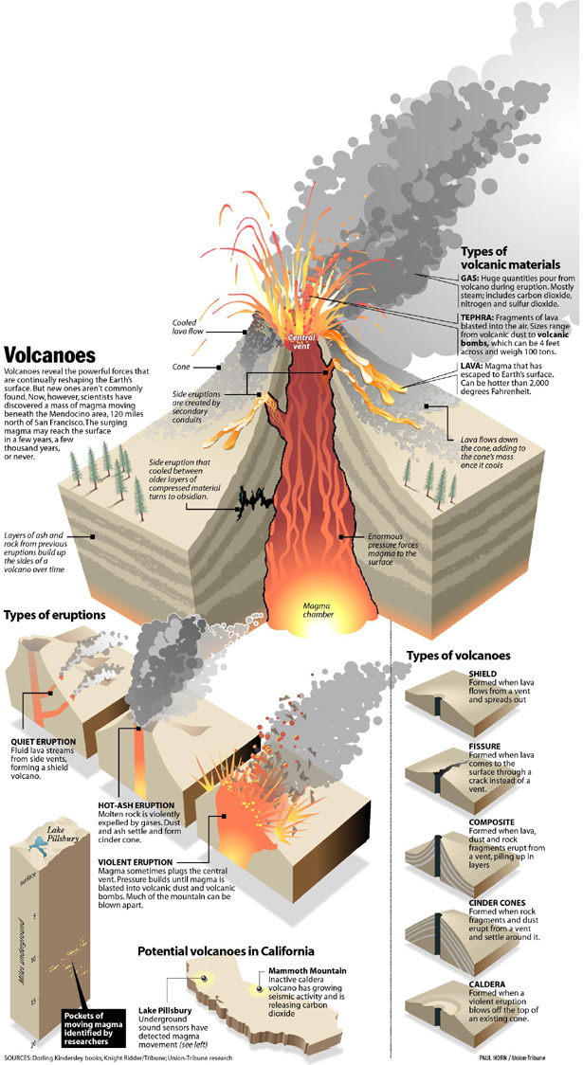](http://graphs.net/wp-content/uploads/2013/11/volcanoes_5029118826d54.jpg)